**Handling of Crisis Overrides**

**Assessor will select the assessment type as Crisis**

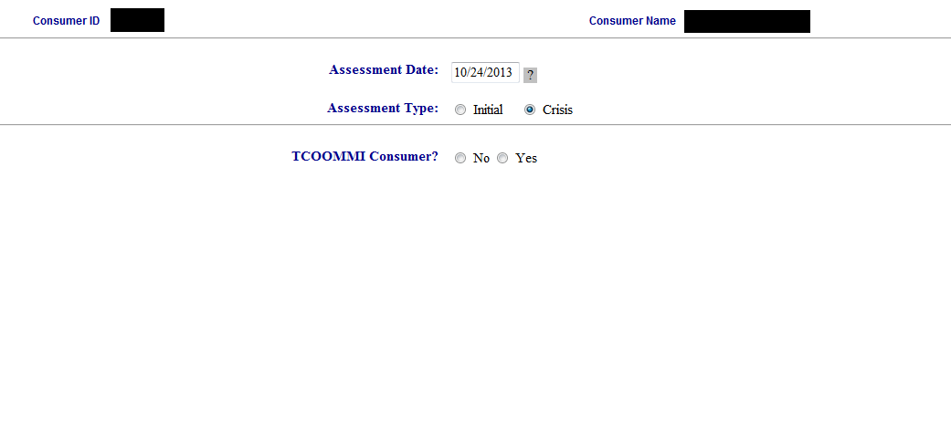

They will score the first set of answers as needed. If they select one of the gray scores they will answer a second set of related questions on the next page. In this example I have picked 0 for first set of questions.

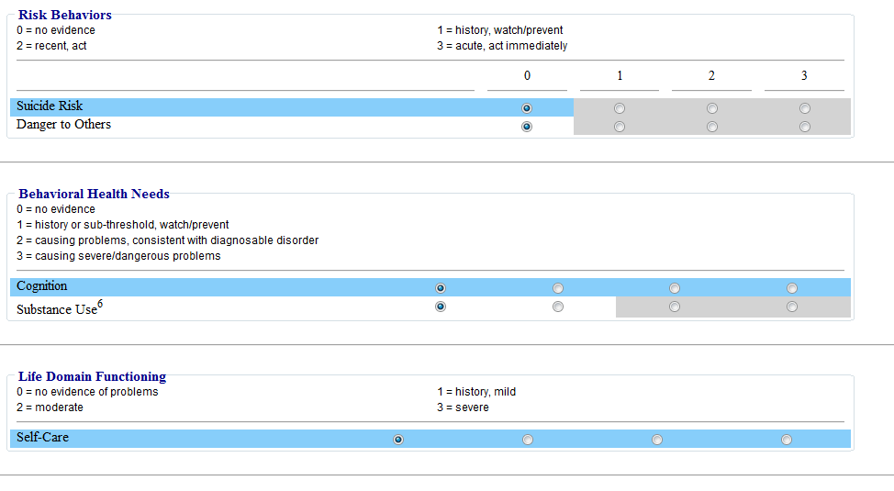

**“Send to UM” Page**

No major changes here from the regular crisis page. However there is a message that the assessment’s recommendation does not compute to Crisis and they will need to request a deviation to Crisis from UM. The default text for this is “Due to scoring not indicating a crisis recommendation, a deviation to Crisis must be requested for authorization “ and can be changed in inc_ANSA, %define CrisisOverTxt1. After clicking Send to UM the assessor is done with their part.

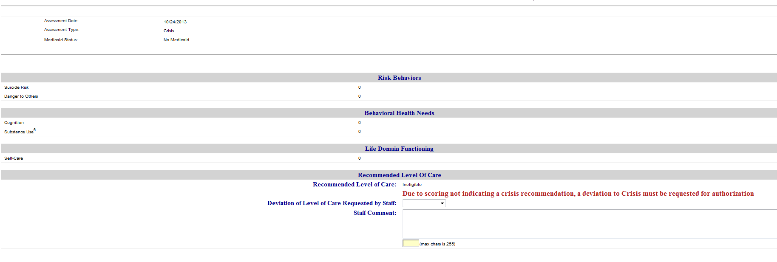

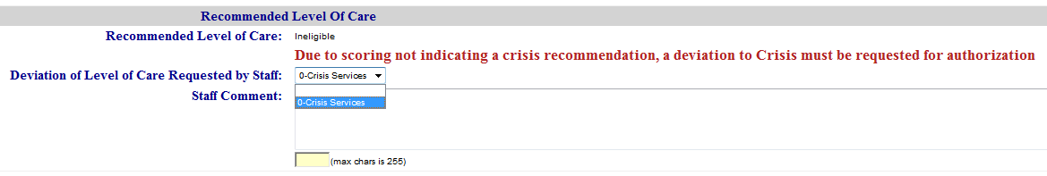

**Authorization**

Text explaining to the authorizer that the scores do not indicate a crisis and that an override must be selected from the dropdown box. Only Crisis and Ineligible are available. The text in red is defined in inc_ANSA so it can be changed.

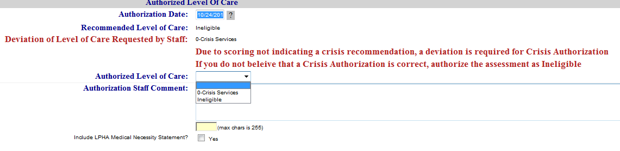

**Assessment authorized as a crisis.**

Snapshot will contain the original Ineligible recommendation and the override deviation request.

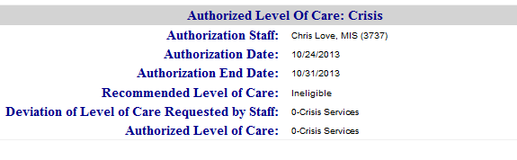

**When saved the DLOC fields and any other deviation fields will be cleared. It’s ready to batch**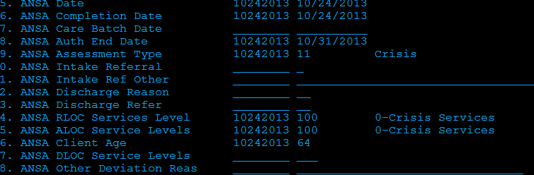

**Same assessment authorized as Ineligible**

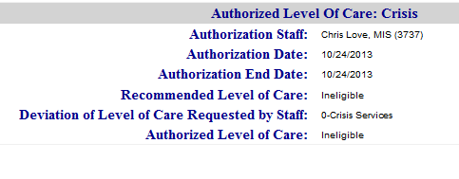

**When the assessment is saved the deviation fields are cleared and the Batch date is set to the authorization date. Also the register is not saved to the Batch pending list.**

